# **Module 5) HTML 5**

1. **What are the new tags added in HTML5?**

* <header>: Defines a header for a document or a section
* <footer>: Defines a footer for a document or a section
* <nav>: Defines a set of navigation links
* <article>: Defines an independent, self-contained content piece, such as a blog post or news article
* <section>: Defines a section in a document
* <aside>: Defines content aside from the content it is placed in
* <figure>: Specifies self-contained content, like illustrations, diagrams,photos,code listings,
* <figcaption>: Defines a caption for a <figure> element
* <main>: Specifies the main conten a document
* <time>: Represents a specific period in time, or a range of time
* <mark>: Highlights text within the context of a document
* <progress>: Represents the progress of a task, typically displayed as a progress bar
* <meter>: Represents a scalar measurement within a known range
* <details>: Defines additional details that the user can view or hide
* <summary>: Defines a visible heading for a <details> element
* <datalist>: Defines a list of pre-defined options for input controls
* <output>: Represents the result of a calculation or user action
* <dialog>: Defines a dialog box or window

**2. How to embed audio and video in a webpage?**

* **Audio**

The <audio> element is used to embed audio. The controls attribute adds playback controls (like play, pause, volume) to the audio player. Inside <audio>, you specify one or more <source> elements, each with a src attribute pointing to the audio file and a type attribute indicating the MIME type of the audio file. You can have multiple <source> elements to provide different formats for compatibility with different browsers.

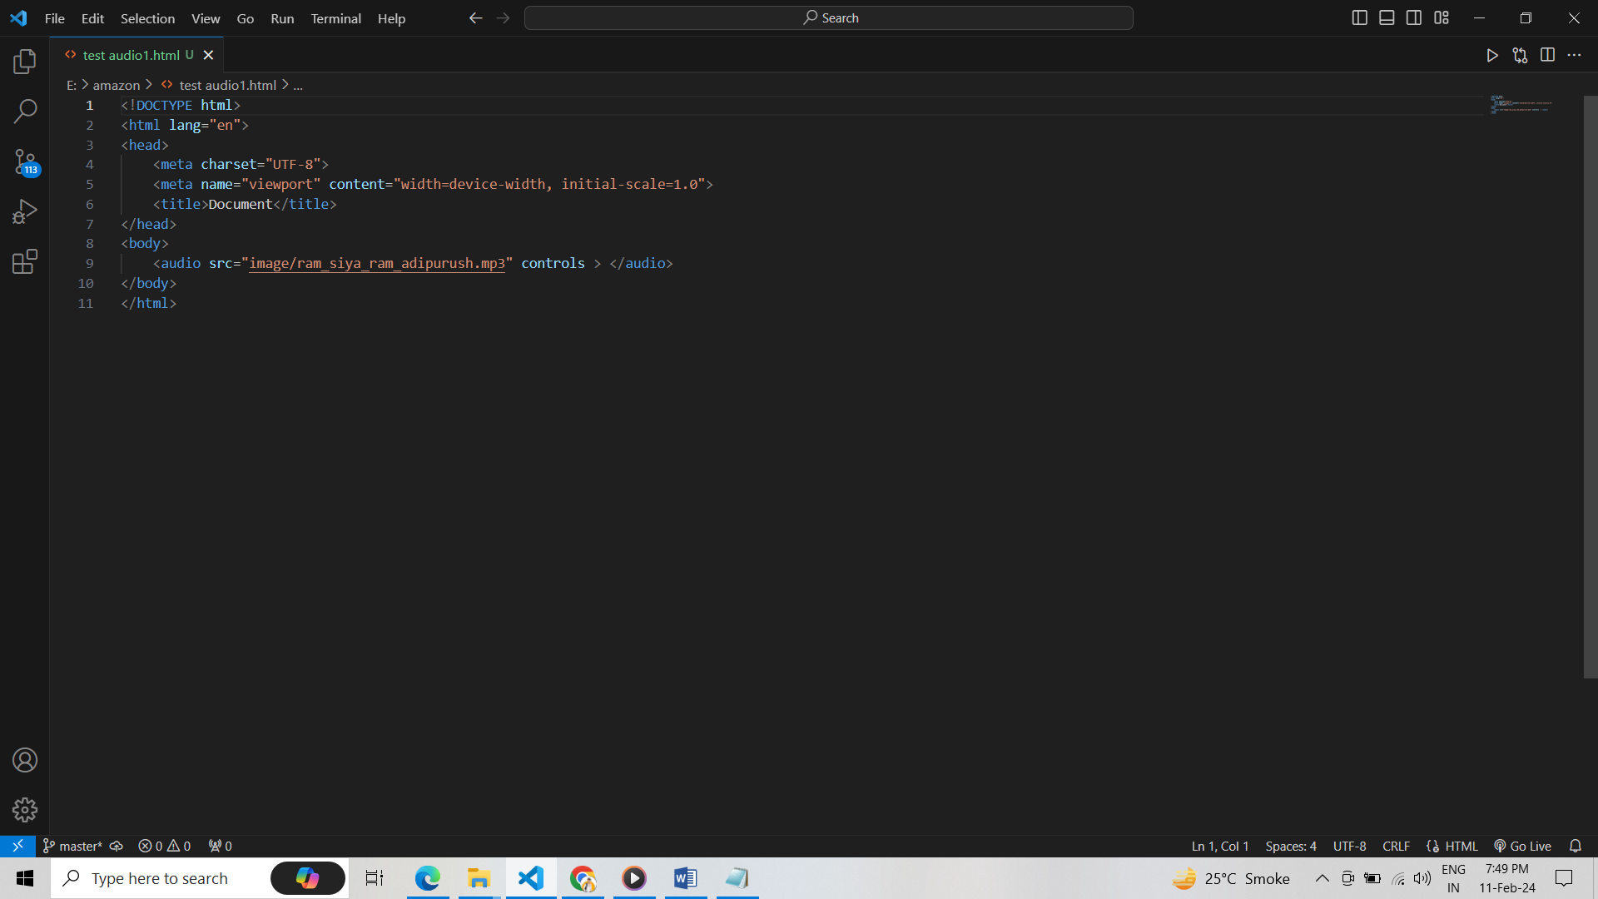

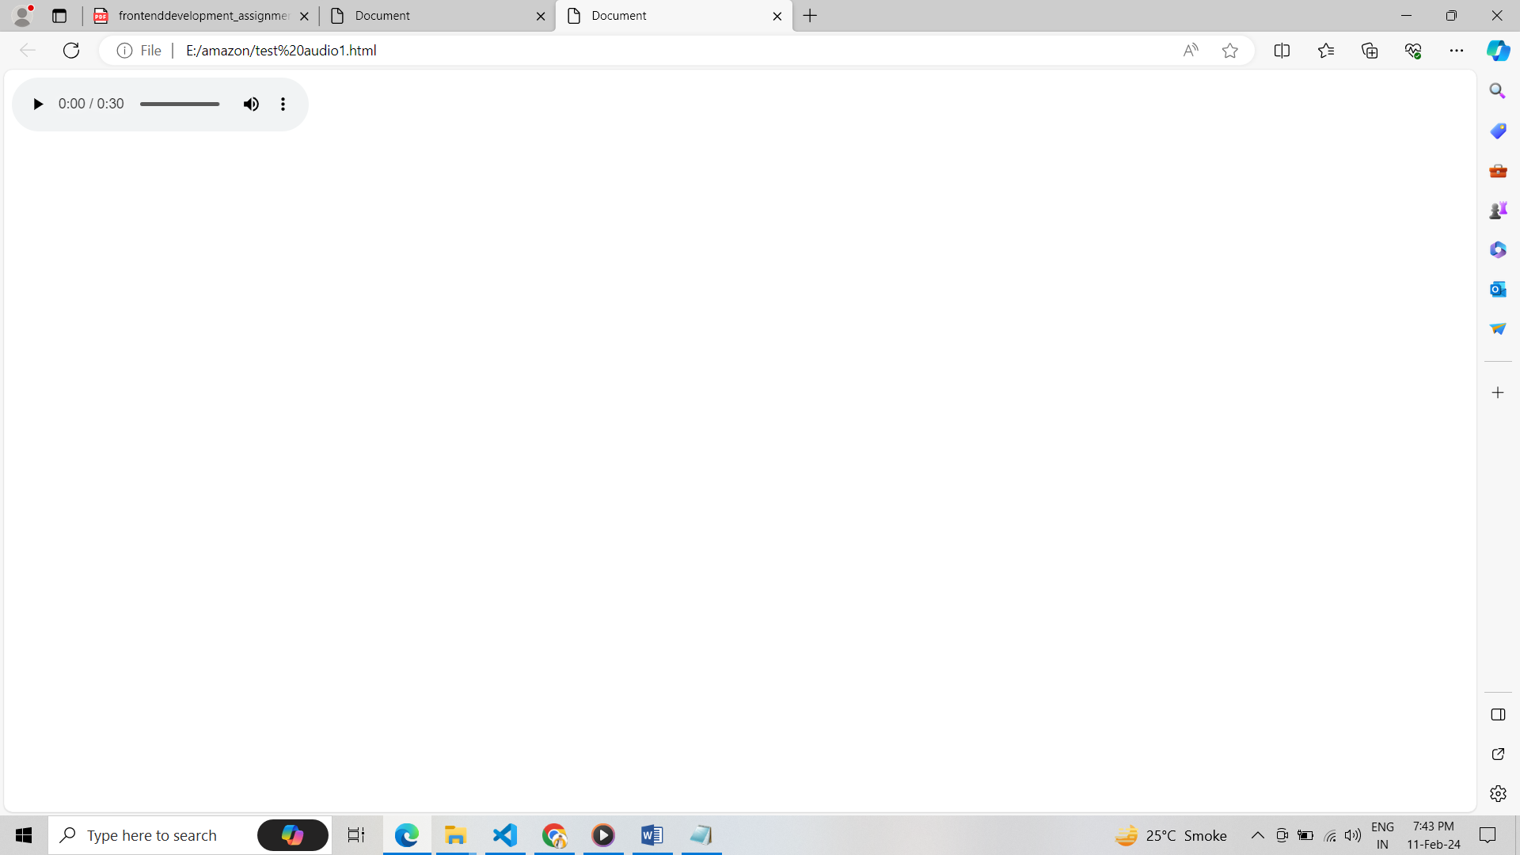

* **Video**

The <video> element is used to embed video. Similar to <audio>, the controls attribute adds playback controls to the video player. Inside <video>, you specify one or more <source> elements with the src and type attributes pointing to the video file and indicating its MIME type. The width attribute sets the width of the video player.

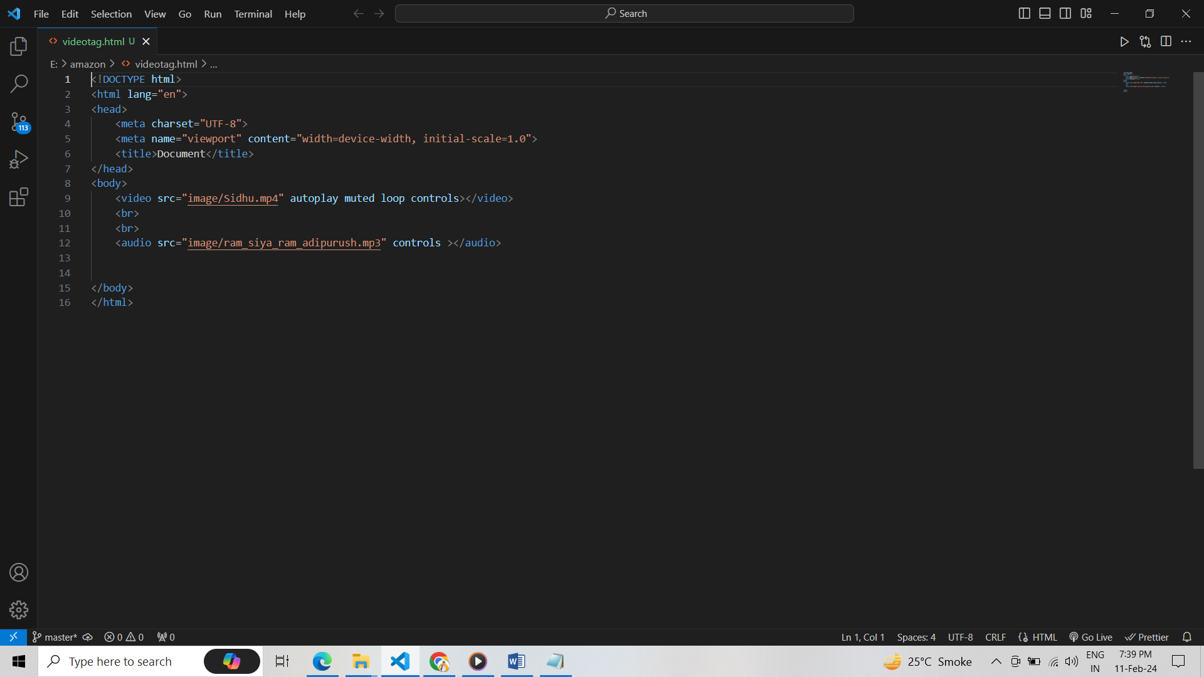

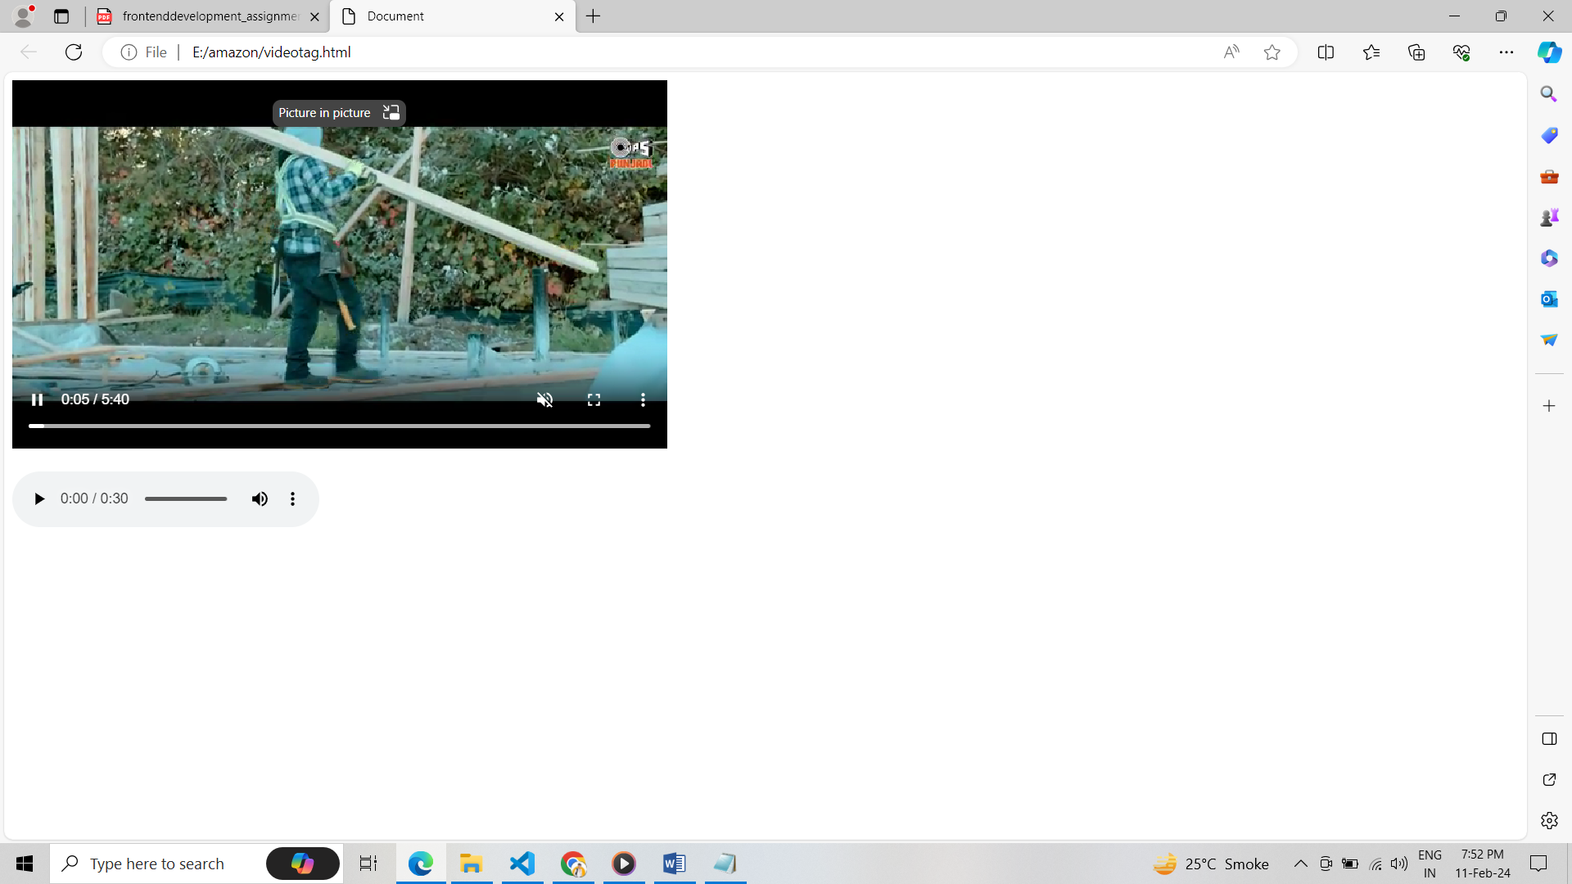

**3. Semantic Element in HTML5?**

* <header>: Represents introductory content at the beginning of a section or a page, often
* containing headings, logos, navigation menus, etc.
* <nav>: Defines a section of navigation links, typically containing links to other pages or
* parts of the same page.
* <main>: Contains the main content of the document. It should not include navigation links,
* headers, footers, or other structural elements.
* <article>: Represents a self-contained piece of content, such as a blog post, forum post, news
* article, etc.
* <section>: Represents a thematic grouping of content within a document. It's often used to
* group related content together.
* <aside>: Represents content that is tangentially related to the content around it, such as

**4. • Canvas and SVG tags**

* **<canvas>**
* <canvas> is a rectangular area on an HTML page where you can draw graphics using
* JavaScript.
* It provides a bitmap-based rendering context, meaning that you work with pixels
* directly.
* You can draw shapes, lines, text, images, and more using JavaScript's Canvas API.
* Canvas is well-suited for dynamic, interactive graphics such as games, data
* visualizations, and real-time animations.
* **<svg>:**
* <svg> stands for Scalable Vector Graphics. It is an XML-based language for describing two-dimensional vector graphics.
* SVG graphics are resolution-independent and can be scaled to any size without losing quality.
* You can create shapes, paths, text, gradients, and more directly within the SVG markup.
* SVG is well-suited for static or less interactive graphics such as icons, logos, illustrations, and diagrams.